Series: Sit. Walk. Stand.
Today: Adventures in Marriage
Speaker: Ronnie Norman, Senior Minister

Ephesians 5:21-33

²¹ Submit to one another out of reverence for Christ.

1. Christian marriage reflects Jesus and the church.

²² Wives, submit yourselves to your own husbands as you do to the Lord. ²³ For the husband is the head of the wife as Christ is the head of the church, his body, of which he is the Savior. ²⁴ Now as the church submits to Christ, so also wives should submit to their husbands in everything.

²⁵ Husbands, love your wives, just as Christ loved the church and gave himself up for her ²⁶ to make her holy, cleansing^{[b]} her by the washing with water through the word, ²⁷ and to present her to himself as a radiant church, without stain or wrinkle or any other blemish, but holy and blameless.

²⁸ In this same way, husbands ought to love their wives as their own bodies. He who loves his wife loves himself.²⁹ After all, no one ever hated their own body, but they feed and care for their body, just as Christ does the church— ³⁰ for we are members of his body. ³¹ “For this reason a man will leave his father and mother and be united to his wife, and the two will become one flesh.”^{[c]} ³² This is a profound mystery—but I am talking about Christ and the church. ³³ However, each one of you also must love his wife as he loves himself, and the wife must respect her husband.

2. The indispensables of marriage empowerment are love and respect.

Crazy Cycle image – link below
http://www.widowspeak.org/wp-content/uploads/2015/03/IMG_1870-e14259368392321.jpg
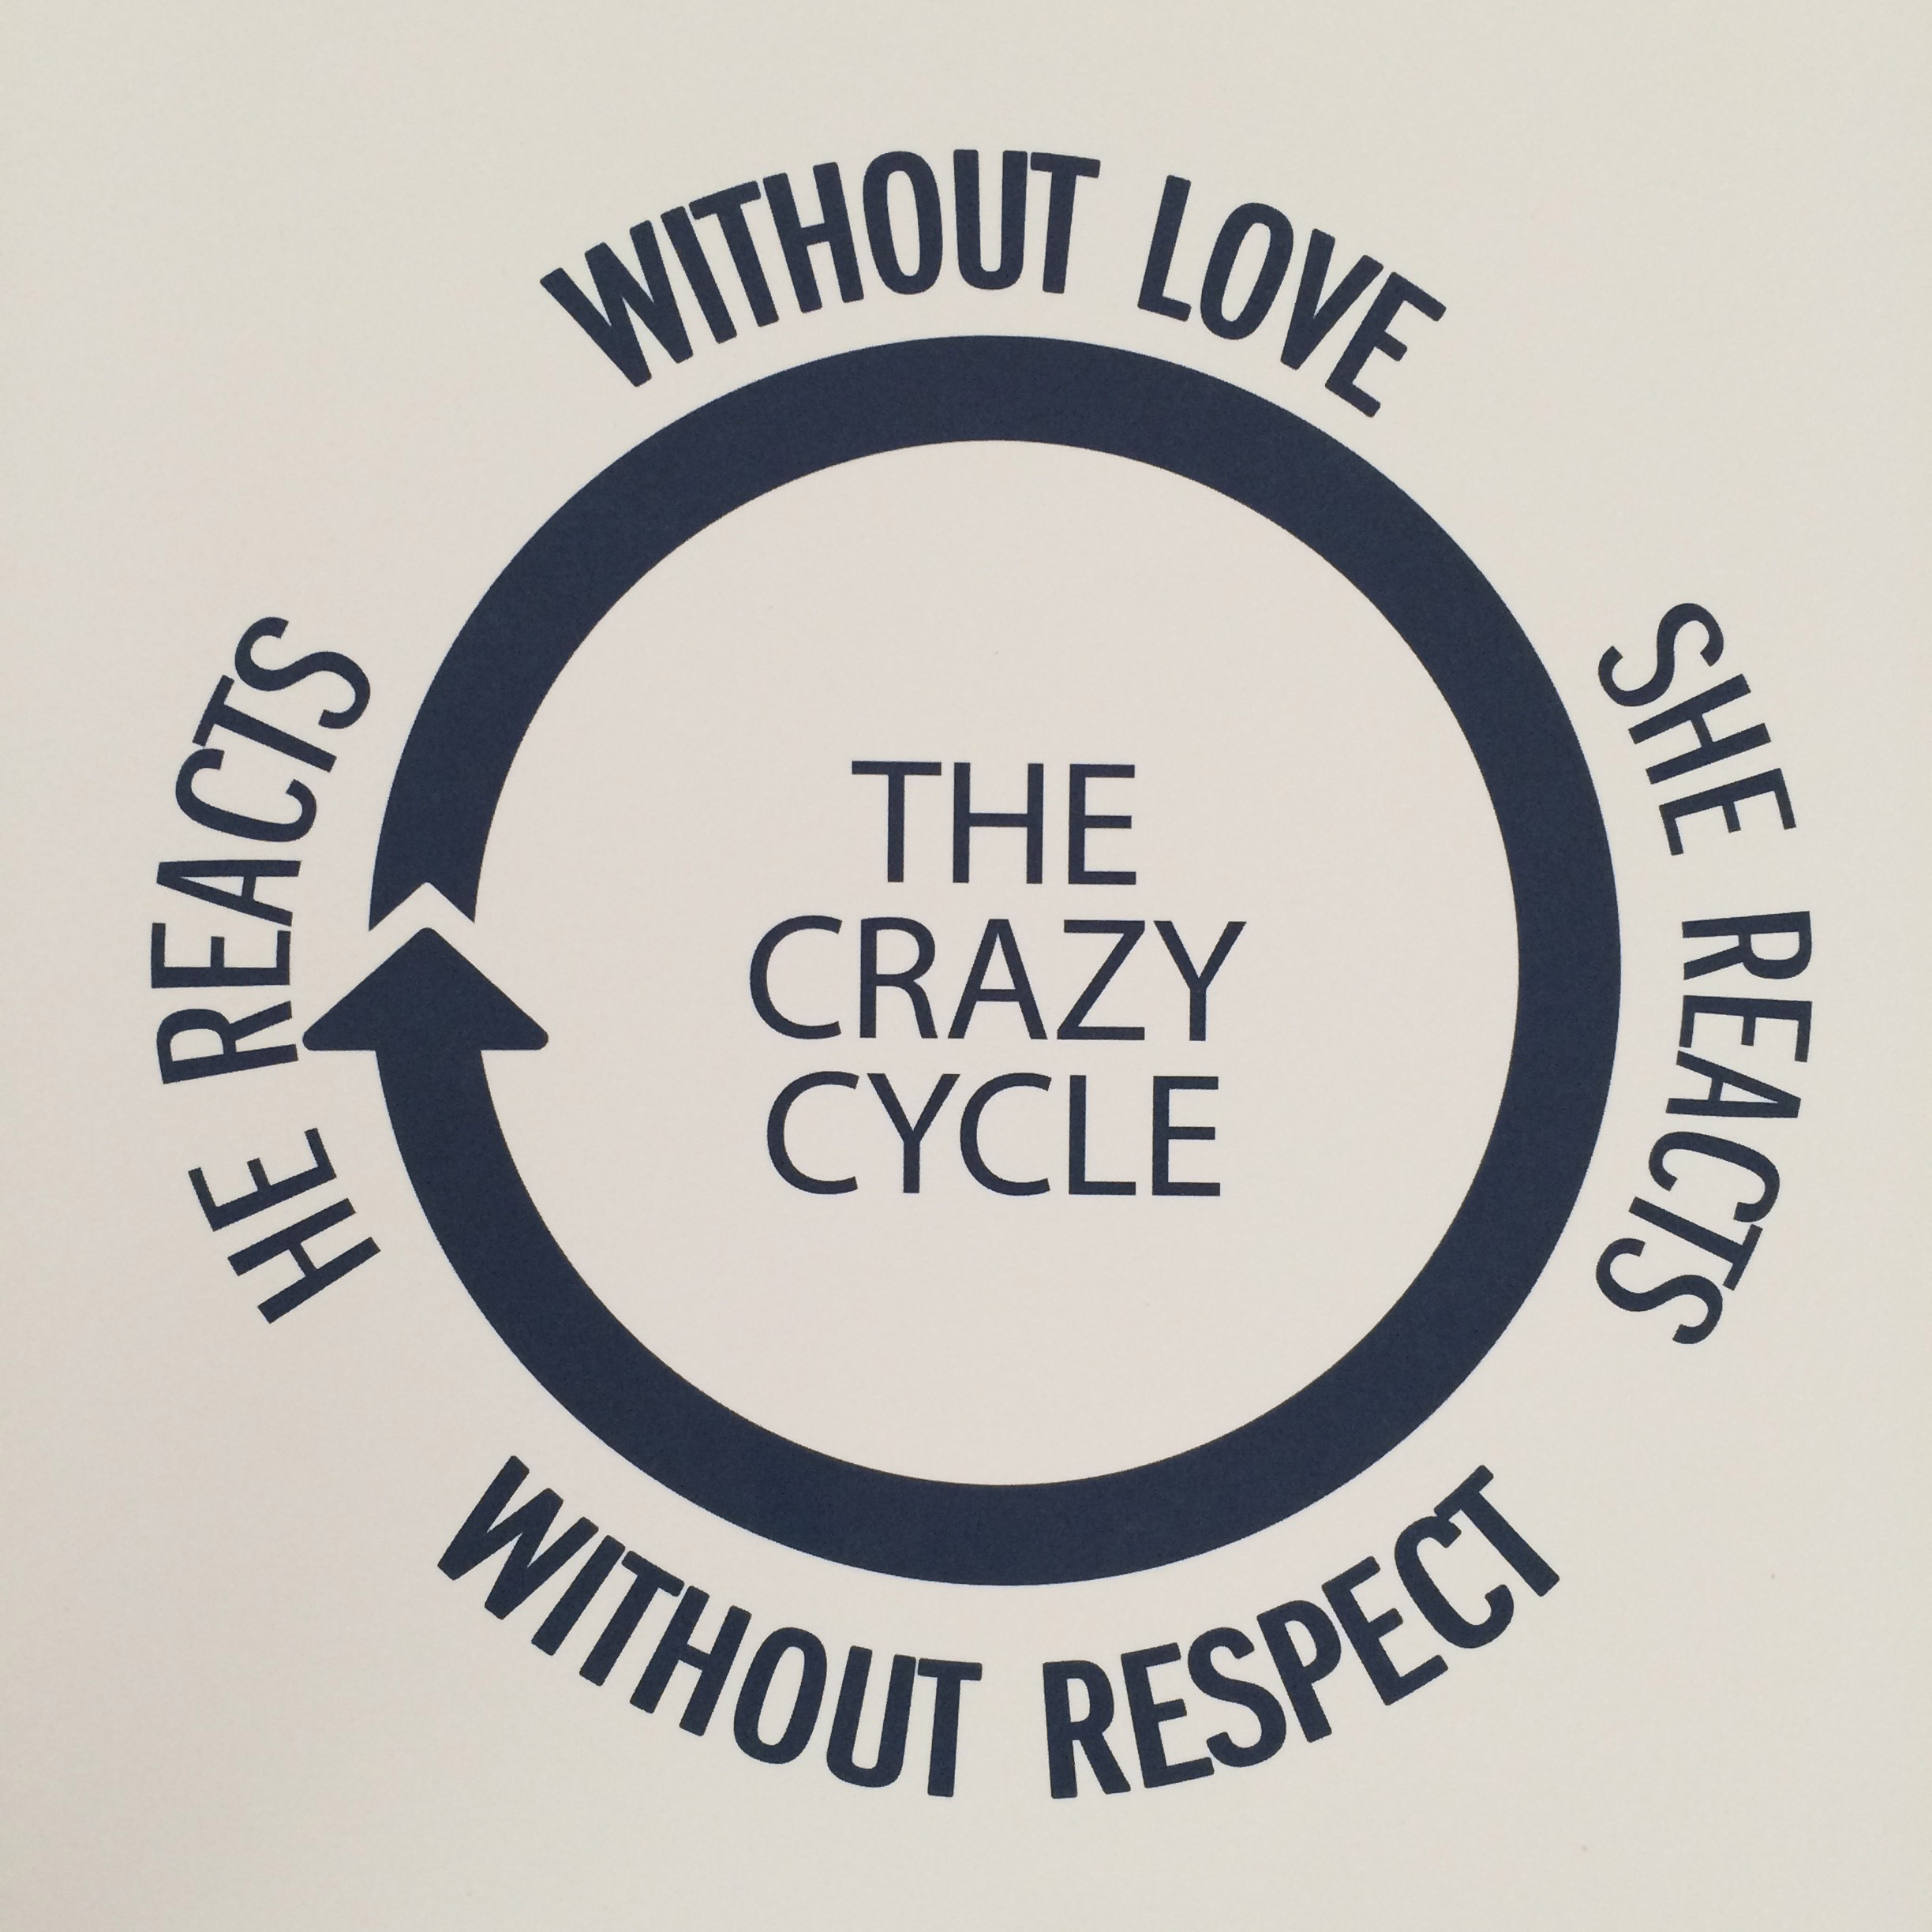

Energizing Cycle image – link below
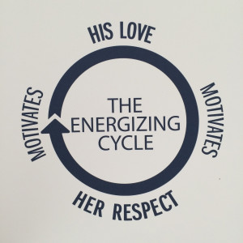
http://www.widowspeak.org/wp-content/uploads/2015/03/IMG_1871-e14259368573111.jpg

3. Five losing strategies to avoid

A. Needing to be right
B. Controlling your spouse
C. Unfiltered self-expression
D. Retaliation
E. Withdrawal

