Series: BELIEVE
Today: Humanity – We’re Only Human
Speaker: Ronnie Norman, Senior Minister

Key Idea: I believe all people are loved by God and need Jesus Christ as their Savior.

1. All of us are broken in various ways.

Romans 3:10-12
¹⁰ As it is written:
“There is no one righteous, not even one;
¹¹ there is no one who understands;
there is no one who seeks God.
¹² All have turned away,
they have together become worthless;
there is no one who does good,
not even one.”

2. All of us are loved by God.

John 3:16
For God so loved the world that he gave his one and only Son, that whoever believes in him shall not perish but have eternal life.

2 Peter 3:9b
…Instead he is patient with you, not wanting anyone to perish, but everyone to come to repentance.

3. All of us can be redeemed through faith in Jesus Christ.

John 3:16
For God so loved the world that he gave his one and only Son, that whoever believes in him shall not perish but have eternal life.

Romans 3:23-24
for all have sinned and fall short of the glory of God, ²⁴ and all are justified freely by his grace through the redemption that came by Christ Jesus.

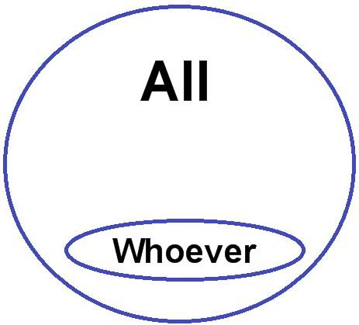

4. All of us can show the love of God from the womb to the tomb.

1 John 4:19-21
¹⁹ We love because he first loved us. ²⁰ Whoever claims to love God yet hates a brother or sister is a liar. For whoever does not love their brother and sister, whom they have seen, cannot love God, whom they have not seen. ²¹ And he has given us this command: Anyone who loves God must also love their brother and sister.

5. All of us can deal with the tension of the real and ideal.

Psalm 103:13-14
¹³ As a father has compassion on his children,
so the Lord has compassion on those who fear him;
¹⁴ for he knows how we are formed,
he remembers that we are dust.

1 John 2:1-2
My dear children, I write this to you so that you will not sin. But if anybody does sin, we have an advocate with the Father—Jesus Christ, the Righteous One. ² He is the atoning sacrifice for our sins, and not only for ours but also for the sins of the whole world.

Deny the bad.

Deny the good.

Attack and judge.

Show love and limits.

6. All of us can point others to Jesus Christ.

