**Title: The King Arrives**

**Speaker: Ronnie Norman**

**Photo**

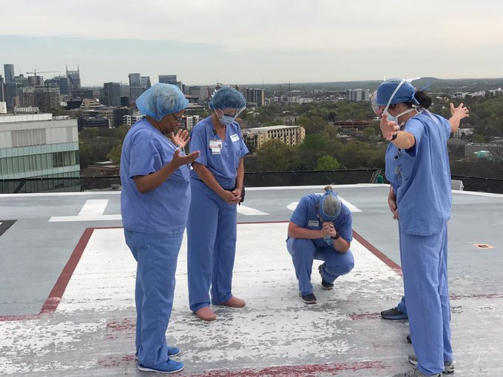

***Mark 11:1-11***

*As they approached Jerusalem and came to Bethphage and Bethany at the Mount of Olives, Jesus sent two of his disciples, 2saying to them, “Go to the village ahead of you, and just as you enter it, you will find a colt tied there, which no one has ever ridden. Untie it and bring it here. 3If anyone asks you, ‘Why are you doing this?’ say, ‘The Lord needs it and will send it back here shortly.’”*

*4They went and found a colt outside in the street, tied at a doorway. As they untied it, 5some people standing there asked, “What are you doing, untying that colt?” 6They answered as Jesus had told them to, and the people let them go. 7When they brought the colt to Jesus and threw their cloaks over it, he sat on it. 8Many people spread their cloaks on the road, while others spread branches they had cut in the fields. 9Those who went ahead and those who followed shouted,*

*“Hosanna!”*

*“Blessed is he who comes in the name of the Lord!”*

*10“Blessed is the coming kingdom of our father David!”*

*“Hosanna in the highest heaven!”*

*11Jesus entered Jerusalem and went into the temple courts. He looked around at everything, but since it was already late, he went out to Bethany with the Twelve.*

**Jesus Is …**

**Brave**

**Humble, but not modest**

<https://www.cardus.ca/assets/data/images/2016/2016_04_Loftus_Crouch.png>

**Gracious**

**Sometimes, the Jesus you want is not the Jesus you get.**

**Have you surrendered to Jesus?**

**IMAGE**

<https://upload.wikimedia.org/wikipedia/commons/6/6f/Keep-calm-and-carry-on-scan.jpg>

**LINK TO OUR FIRST CONVERSATIONS BIBLE STUDY SLIDE**