Series: Vice Grip
Today: Green with Envy
Speaker: Ronnie Norman, Senior Minister

Green Eye Image https://www.google.com/url?sa=i&url=http%3A%2F%2Fwww.catholiclane.com%2Fthe-politics-of-envy%2Fgreen-eye-of-envy%2F&psig=AOvVaw1D_yxcj4yU0WQLmxiolWOk&ust=1601667155263000&source=images&cd=vfe&ved=0CAIQjRxqFwoTCKDNmKeRlOwCFQAAAAAdAAAAABAY

SEVEN CAPITAL VICES
Envy
Vainglory
Sloth (Acedia)
Avarice (Greed)
Anger
Gluttony
Lust

Amadeus Image https://external-content.duckduckgo.com/iu/?u=https%3A%2F%2Fvjmorton.files.wordpress.com%2F2012%2F02%2Famadeussalieri.jpg&f=1&nofb=1
Proverbs 14:30
A heart at peace gives life to the body, but envy rots the bones.

James 3:16
For where you have envy and selfish ambition, there you find disorder and every evil practice.

Matthew 27:18
Pilate knew very well that the religious leaders had arrested Jesus out of envy.

Envy Continuum (adjust the copy below of a previous version by omitting the number one and the “what is envy” question. Also make the word Envy singular.
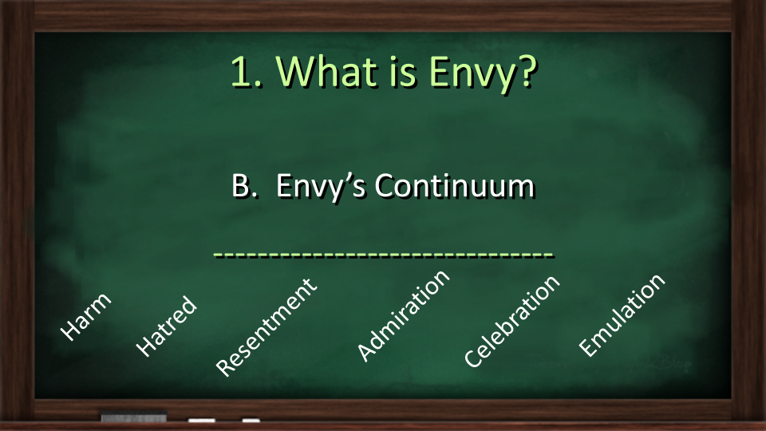

Beware the Comparison Trap
2 Corinthians 10:12
We do not dare to classify or compare ourselves with some who commend themselves. When they measure themselves by themselves and compare themselves with themselves, they are not wise.

Tame this Green Monster?
- Acknowledge your deep need for unconditional love
- Replace envy with productive zeal
- Practice gratitude
- Practice hidden acts of love
- Give God permission
“Love your neighbor as yourself.” - Jesus

