Series: Family Dynamics
Today: Reverse Engineering Marriage
Speaker: Ronnie Norman

1. The Story Behind Our Stories
Mark 10:2-12 (NIV)
² Some Pharisees came and tested him by asking, “Is it lawful for a man to divorce his wife?”
³ “What did Moses command you?” he replied.
⁴ They said, “Moses permitted a man to write a certificate of divorce and send her away.”
⁵ “It was because your hearts were hard that Moses wrote you this law,” Jesus replied. ⁶ “But at the beginning of creation God ‘made them male and female.’^{[a]7} ‘For this reason a man will leave his father and mother and be united to his wife,^{[b]} ⁸ and the two will become one flesh.’^{[c]} So they are no longer two, but one flesh.⁹ Therefore what God has joined together, let no one separate.”
¹⁰ When they were in the house again, the disciples asked Jesus about this. ¹¹ He answered, “Anyone who divorces his wife and marries another woman commits adultery against her. ¹² And if she divorces her husband and marries another man, she commits adultery.”

Following points are PP only
Friendship
Productivity
Sexuality
Family
Joy
2. Are You Relationally Wise?
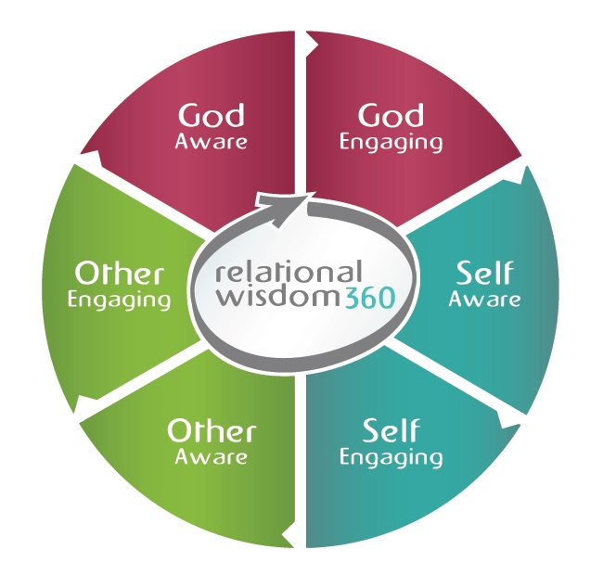
3. Take These Home
A. Adapt to your spouse more than you adapt to others.
B. Forgive your spouse more eagerly than you forgive others.
C. Treat your spouse better than you treat anyone else.
D. Treat your marriage as holy territory.
1 John 4:10 (NIV)
¹⁰ This is love: not that we loved God, but that he loved us and sent his Son as an atoning sacrifice for our sins.

