Series: Acts: Spirit. Mission. Drama
Today: Are You the Christian Type?
Ronnie Norman, Senior Minister
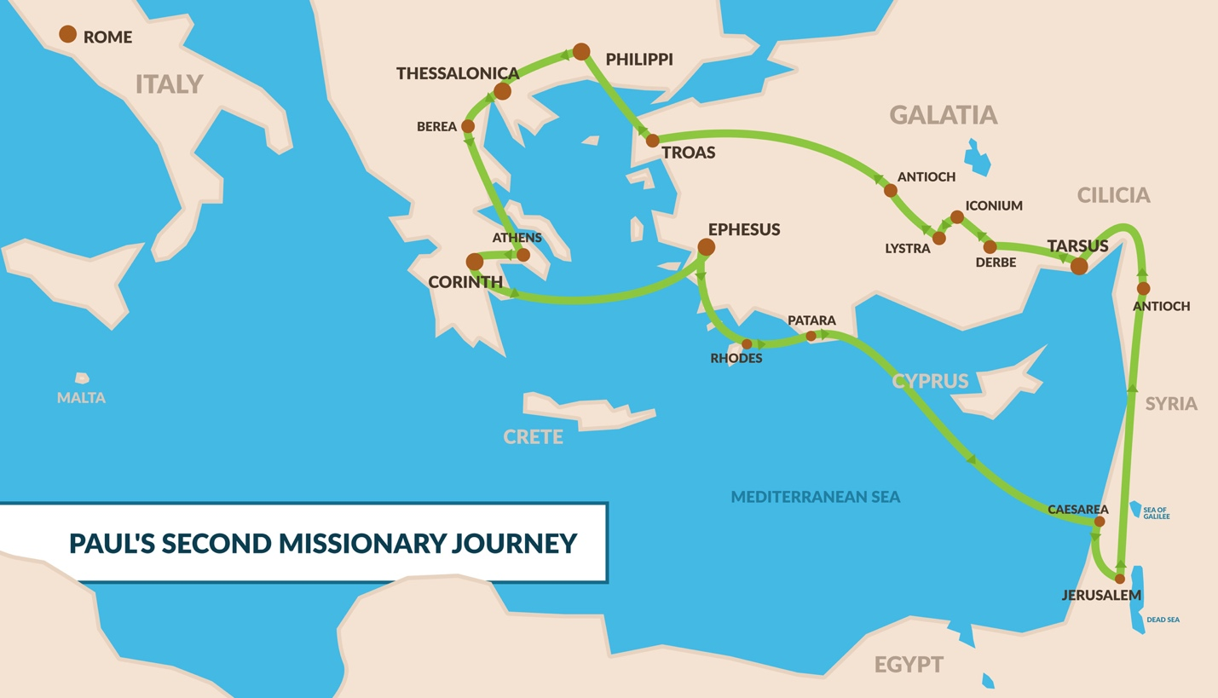
Acts 16:9-34
⁹ During the night Paul had a vision of a man of Macedonia standing and begging him, “Come over to Macedonia and help us.” ¹⁰ After Paul had seen the vision, we got ready at once to leave for Macedonia, concluding that God had called us to preach the gospel to them.
¹¹ From Troas we put out to sea and… traveled to Philippi, a Roman colony and the leading city of that district of Macedonia. And we stayed there several days.
¹³ On the Sabbath we went outside the city gate to the river, where we expected to find a place of prayer. We sat down and began to speak to the women who had gathered there. ¹⁴ One of those listening was a woman from the city of Thyatira named Lydia, a dealer in purple cloth. She was a worshiper of God. The Lord opened her heart to respond to Paul’s message.
¹⁵ When she and the members of her household were baptized, she invited us to her home. “If you consider me a believer in the Lord,” she said, “come and stay at my house.” And she persuaded us.
¹⁶ Once when we were going to the place of prayer, we were met by a female slave who had a spirit by which she predicted the future. She earned a great deal of money for her owners by fortune-telling. ¹⁷ She followed Paul and the rest of us, shouting, “These men are servants of the Most High God, who are telling you the way to be saved.” ¹⁸ She kept this up for many days. Finally Paul became so annoyed that he turned around and said to the spirit, “In the name of Jesus Christ I command you to come out of her!” At that moment the spirit left her.
¹⁹ When her owners realized that their hope of making money was gone, they seized Paul and Silas and dragged them into the marketplace to face the authorities. ²⁰ They brought them before the magistrates and said, “These men are Jews, and are throwing our city into an uproar ²¹ by advocating customs unlawful for us Romans to accept or practice.”
²² The crowd joined in the attack against Paul and Silas, and the magistrates ordered them to be stripped and beaten with rods. ²³ After they had been severely flogged, they were thrown into prison, and the jailer was commanded to guard them carefully. ²⁴ When he received these orders, he put them in the inner cell and fastened their feet in the stocks.
²⁵ About midnight Paul and Silas were praying and singing hymns to God, and the other prisoners were listening to them. ²⁶ Suddenly there was such a violent earthquake that the foundations of the prison were shaken. At once all the prison doors flew open, and everyone’s chains came loose. ²⁷ The jailer woke up, and when he saw the prison doors open, he drew his sword and was about to kill himself because he thought the prisoners had escaped. ²⁸ But Paul shouted, “Don’t harm yourself! We are all here!”
²⁹ The jailer called for lights, rushed in and fell trembling before Paul and Silas. ³⁰ He then brought them out and asked, “Sirs, what must I do to be saved?”
³¹ They replied, “Believe in the Lord Jesus, and you will be saved—you and your household.” ³² Then they spoke the word of the Lord to him and to all the others in his house. ³³ At that hour of the night the jailer took them and washed their wounds; then immediately he and all his household were baptized. ³⁴ The jailer brought them into his house and set a meal before them; he was filled with joy because he had come to believe in God—he and his whole household.
- Plan in pencil.

- The Gospel is for everyone!

- Give God an opportunity to open a heart.
“The Lord opened her heart to respond to Paul’s message.” – Acts 16:14
- Seasons of trouble are platforms for ministry.

