Acts: Spirit. Mission. Drama.
Today: Irrepressible
Ronnie Norman, Senior Minister

Acts 18:1-11
After this, Paul left Athens and went to Corinth.

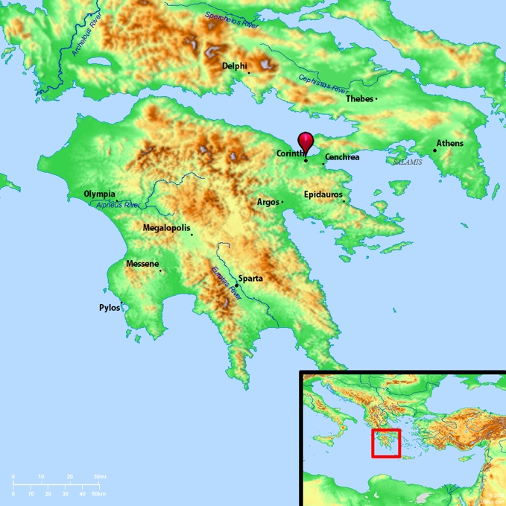Map of Corinth
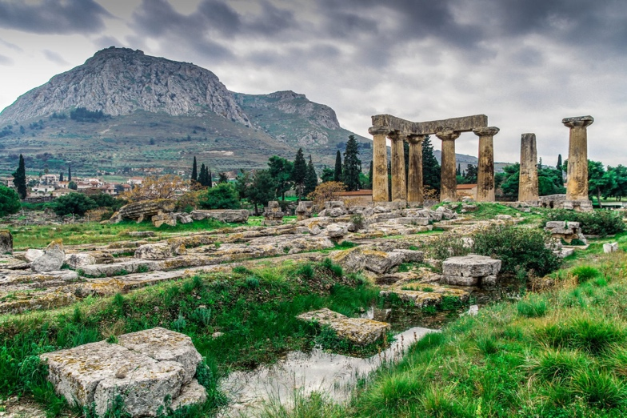Corinth Ruins

² There he met a Jew named Aquila, a native of Pontus, who had recently come from Italy with his wife Priscilla, because Claudius had ordered all Jews to leave Rome. Paul went to see them, ³ and because he was a tentmaker as they were, he stayed and worked with them. ⁴ Every Sabbath he reasoned in the synagogue, trying to persuade Jews and Greeks.

- We are not dust in the wind.

⁵ When Silas and Timothy came from Macedonia, Paul devoted himself exclusively to preaching, testifying to the Jews that Jesus was the Messiah. ⁶ But when they opposed Paul and became abusive, he shook out his clothes in protest and said to them, “Your blood be on your own heads! I am innocent of it. From now on I will go to the Gentiles.”

- We are not overcome by opposition.

⁷ Then Paul left the synagogue and went next door to the house of Titius Justus, a worshiper of God. ⁸ Crispus, the synagogue leader, and his entire household believed in the Lord; and many of the Corinthians who heard Paul believed and were baptized.

⁹ One night the Lord spoke to Paul in a vision: “Do not be afraid; keep on speaking, do not be silent.

- We need not be slaves to fear.

- We will not be silent.

¹⁰ For I am with you, and no one is going to attack and harm you, because I have many people in this city.”

- We are not alone – God is with us!

- We will not be stopped!

¹¹ So Paul stayed in Corinth for a year and a half, teaching them the word of God.

