FIRST COLONY CHURCH OF CHRIST – OCTOBER 2013
WORKING 9 TO 5: WHAT A WAY TO MAKE A DIFFERENCE!

- Video: Work as Worship – 2:33
00 Opening Remarks
- Greetings from the campus (ACU/COBA)
- Thanks – Eric Fridge for inviting me to speak with you
- Thanks to my family and my God – you are the wind beneath my wings!

01 The world is in desperate need of your Work. Work which:
- Reveals GOD: excellent – distinctive – kingdom created work!
  - That they may see your good Work and glorify God (Matt 5:16)
- Living sacrifice – holy/pleasing to God: your spiritual act of worship (Rom. 12:1)
- Earns you the Mic – the right to be heard (M. Albers, Exxon)

- God’s View of Work: the form in which we make ourselves useful to others.
- Genesis 1:1 – created, crafted, labored, moved
- John 5:17 – he is always at work
- Scriptures…

- Your life’s work… begins with your perspective!
- Girl and Whales
- Ferdinand Porsche – Cathedral
- Johnny the Bagger - dis-connect between Sunday and Monday – not Jesus!
07 Video: The Invisible Woman – 5:36
12 Jesus said it this way…
  - Matthew 6:22, If your eyes are good, your whole body…
  - Sermon on the Mount… you have heard it said, but I tell you…
  - Matthew 7:13, Enter through the narrow gate. For wide is gate…

16 What Do You See?
- Michelle: VB & Track – a calling, uses to glorify God & help her team win
- Vaclev Havel, 1st pres. of Czech Republic, history working through me, velvet revolution
- Ronald Reagan (40th US Pres.), morning in America, rendezvous with destiny
- Condoleezza Rice (66th US Sec of State) – no hamburgers in Woolworths in Birmingham, AL, her DADDY said she could be president of the U.S.

18 Not About Winning – It’s About Working: Mom and Dad
- Parable of Talents (Matt. 25:14)
    - 5,2,1 – entrusted with these, put them to work!
    - It’s not about how many, it’s about what you do (Luke 12:48).
    - Sweep under the Candy Racks (faithful in a few things…)
  - Fig tree – after triumphal entry, early in the morning, no fruit, he cursed the tree and it died (Matthew 21:18)
  - Vineyard Tenants – kingdom will be taken away and given to those who produce fruit (Matt. 21:43)

25 Max Lucado – Crayons and Jesus
- Your calling/work is to bring Jesus to life in living color with the crayons God has given you!

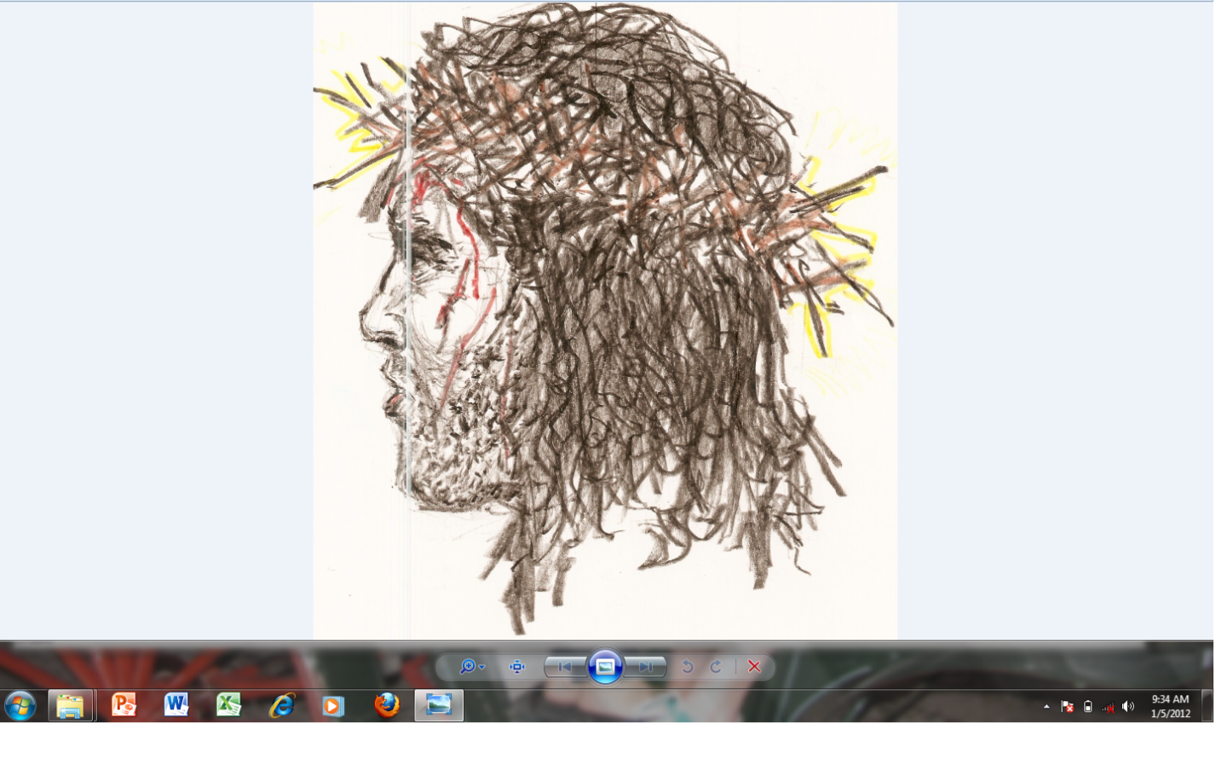
COBA Scripture: Whatever you do, work at it with all your heart, as working for the Lord, not for men, since you know that you will receive an inheritance from the Lord as a reward. It is the Lord Christ you are serving.” (Col. 3:23)

